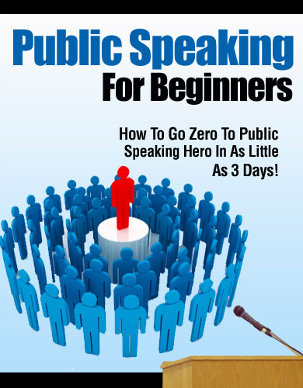

LIMITS OF LIABILITY / DISCLAIMER OF WARRANTY:

The Authors has strived to be as accurate and complete as possible in the creation of this manual, notwithstanding the fact that he does not warrant or represent at any time that the contents within are accurate due to the rapidly changing nature of the Internet.

While all attempts have been made to verify information provided in this publication, the Authors assume no responsibility for errors, omissions, or contrary interpretation of the subject matter herein. Any perceived slights of specific persons, peoples, or organizations are unintentional.

There are no guarantees of income made. Readers are cautioned to reply on their own judgment about their individual circumstances to act accordingly. This book is not intended for use as a source of legal, business, accounting or financial advice. All readers are advised to seek services of competent professionals in legal, business, accounting, and finance field.

Screen shots seen in this manual are from publicly accessible files and web pages and used as “fair use” for reporting purposes and to illustrate various points mentioned herein. Texts and images available over the Internet may be subject to copyright and other intellectual rights owned by third parties.

Day 1

Speaking in front of people, large crowds in particular, is usually perceived as the most stressful experience imaginable. The following ideas in this course are designed to help you, or anyone for that matter, convey your ideas and messages to either one person, or a large group in just about any setting. Creating an effective presentation, can seem very overwhelming. But here are strategies you can use to come up with an effective and powerful speech in 30 minutes or less, regardless of your target audience.

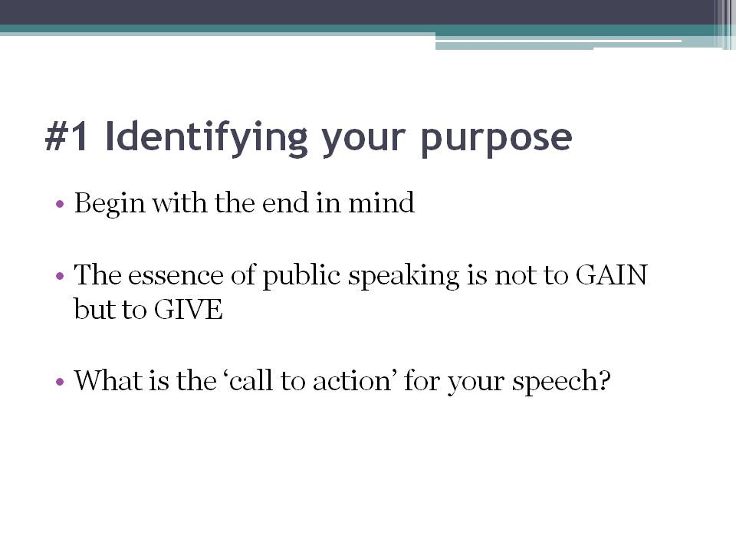

#1 Identifying your purpose

The importance of goal-setting must not be overlooked when preparing for any presentation. The very first thing you need do before you even embark on your presentation is to define your objectives. It is crucial that you begin with the end in mind. Ask yourself this, “What do I want to achieve from my speech?”, “What do I want my audience to receive?”, “What do I want my audience to do next?”

The first thing you need to do in the speech preparation process is to identify your purpose. The purpose of your presentation can range from creating awareness, fostering understanding, generating impact, selling a product, or even to inspire your audience. Remember that the main reason why you’re presenting in the first place is to give, not just gain. As such, your goals should be aligned with allowing your audience to benefit from your presentation. Your purpose-setting must be extremely clear, not just to yourself, but to your audience as well. This helps them internally craft the benefits they will gain from listening to you.

The biggest mistake of public speaking is when you start with the wrong purpose in mind. Mediocre speakers operate without a specific purpose which can easily cause stress and anxiety. The nature of your purpose is just as important as the purpose itself. Many speakers often mistakenly assume or even subconsciously decide that their purpose is audience validation and approval. Wrong. This is completely foolish. This causes great pressure on the speaker to be absolutely perfect in order to win unanimous approval and this causes a great deal of anxiety. I call this a “stress-producing” purpose.

Once you’ve established the purpose of your presentation, you can easily craft your presentation around it in order for it to be achieved. Remember that the essence of public speaking is not to GAIN something, but to GIVE something. When you operate with that frame of mind, you automatically tune your body language, tone of voice and craft content that is useful for your audience. With that, you immediately attract the attention of the majority.

To conclude this section, here’s a quick summary. Before even writing your speech, you need to clearly define your objectives and ask yourself, “What do you want to achieve with this?” and to set goals that benefit not just yourself, but your audience as well. Now that you’ve identified the purpose of your speech, you can move on to the next stage.

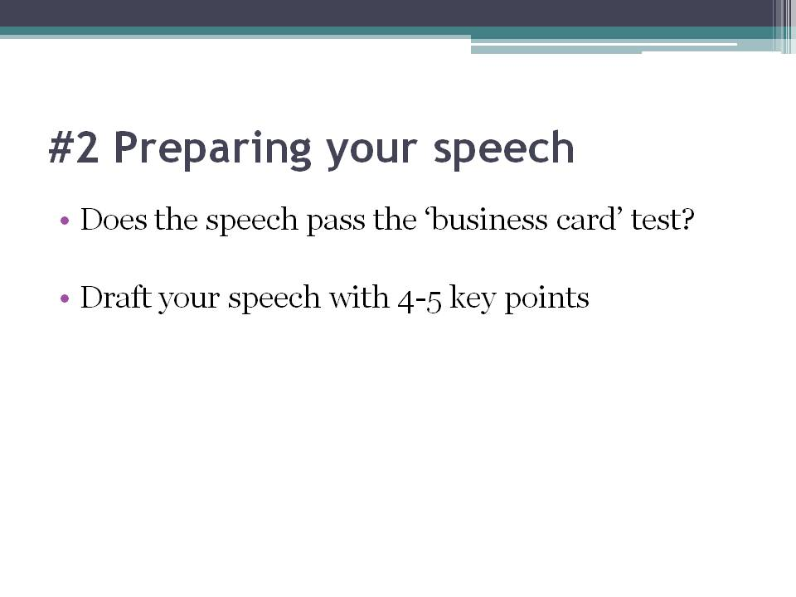

#2 Preparing your speech

Now that you’ve identified the purpose of your speech, it’s time you craft it. But before you do, it’s important to clarify your topic. One way to make sure you’ve got it all cleared up is to try out the “business card test” - can you state your main idea on only one side of a business card? If you can, you’re ready to move on. If you can’t, keep working on it until you can.

Now, you can start drafting your speech. Grab a sheet of paper and right at the top of the page, clearly state your desired topic and the goal of your presentation. Then move on to write your opening lines and follow that up with 4-5 key points. Back these points up and summarize them in the conclusion. This is your outline. Now that you’ve listed your most important subjects, you can begin crafting your presentation based on the completed outline.

Before you start writing that speech out proper, let’s take a quick detour, and visit one of the greatest and most notable speeches made in human history - yes, Martin Luther King, Jr.’s “I Have A Dream”. Did you know that the most important, most often-quoted and the most powerful part of his entire speech, his iconic “I have a dream” statement, was made only in the last quarter of his entire powerful presentation? It makes you wonder how he managed to capture the full attention of over 200, 000 agitated, and angry civil rights supporters? If you were thinking that it was his authority, you’re wrong. And it wasn’t his looks either. Reverend King had a powerful introduction. He started with this, “Five score years ago, a great American, in whose symbolic shadow we stand today, signed the Emancipation Proclamation. This momentous decree came as a great beacon light of hope to millions of Negro slaves who had been seared in the flames of withering injustice. It came as a joyous daybreak to end the long night of their captivity.”

Martin Luther King, Jr. started his powerful speech with a strong, passionate story which set the mood for the rest of his speech. When you begin crafting your speech, you have to remember that the most important part is your introduction. If your audience’s attention is not captured within the first 30 seconds, you’re pretty much history. Your introduction can make, or break, your entire speech. Remember that a strong opening is King, pun unintended. You may start with a probing question, a strong statement, a personal story or even a quote. These elements not only set the mood for your speech, but also pique your audience’s attention and focus sufficiently to hook them for the rest of what you have to say.

Now that you’ve crafted a powerful introduction, you can move on to the core points of your speech. Each of these points should be backed by interesting stories, illustrations, historical references, humorous anecdotes, and examples that the audience may be able to relate to. Common stories or illustrations include references to common childhood occurrences, growing up pains or even teenage experiences. You can use these stories and examples to further reinforce your point. Humans are sensory creatures. If you’re able to pique more than just one sense - their hearing - you’ve got them hooked, forever. Remember to include descriptives in your stories and even images for the visual ones in your audience. Analogies help your audience connect the dots of your points in their heads. Also remember to open and close each point with a clear transition. This makes it easier for your audience to follow your story. For those of you who’re selling to or motivating your audience, you may even address your audience’s pain, stress on the benefits of taking immediate actions, suggest a recommended course of action followed by closing remarks.

Now that you’ve detailed all the main points of your speech, you can start to write your close. A common, but effective, conclusion is a summary. This can be followed by an appeal or a call to action to challenge your audience, which is completely dependent on your purpose and topic. Run a quick summary by your audience and if necessary, outline clear guidelines and next actions they can take with the information you’ve just given them so that they do not feel like they’ve left your speech with nothing concrete to take with them.

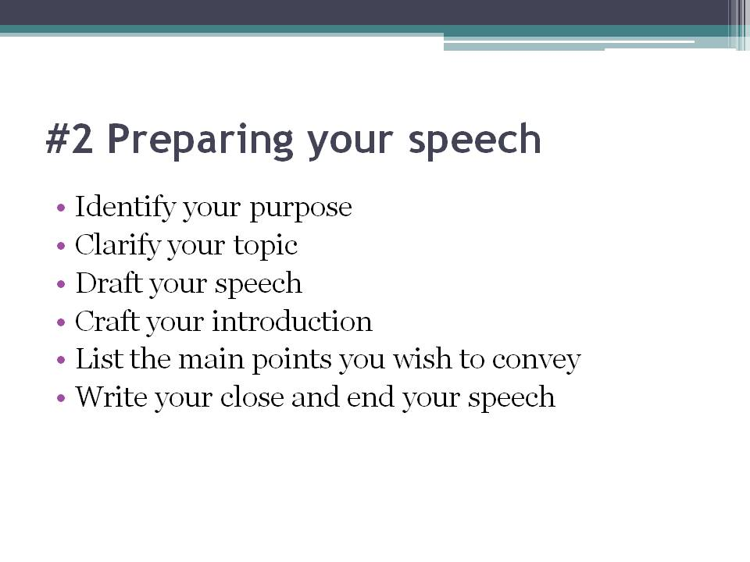

Here’s a quick summary of the preparation process: 1. Identify your purpose, 2. Clarify your topic, 3. Draft your speech, 4. Craft your introduction, 5. List the main points you wish to convey, and 6. Write your close and end your speech with clear step-by-step or listed guides or next actions for your audience.

Let’s move on to the next part of this session.

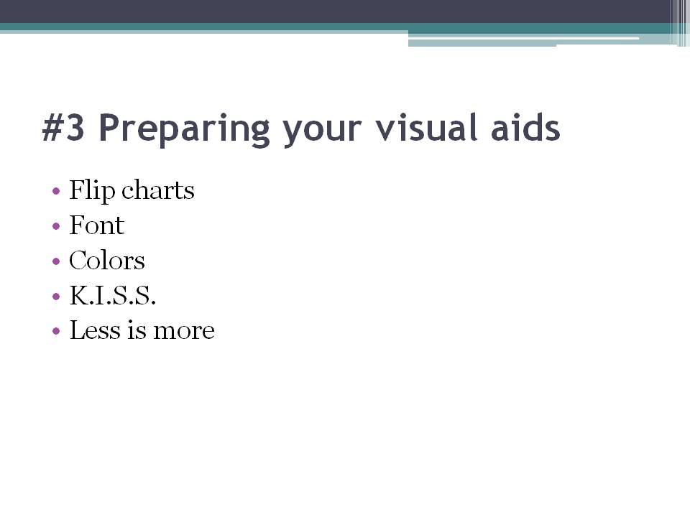

#3 Preparing your visual aids

In Martin Luther King, Jr.’s time, visual aids weren’t just a luxury - they were an hassle, and in some cases, an impossibility. Thanks to technological advances today, you have projectors in almost every main hall of a speaking event, or a white board with markers at the very least. As such, it’s no excuse to not have visual aids accompanying your speech.

Why are visual aids so important? They stimulate another one of your audience’s senses and forces their brain to link the two together. This inadvertently helps keep them awake and focused throughout your speech. Most importantly, they allow you to further reinforce your points to your audience, and increase the number of associations their brain makes which can heighten your audience’s recall of your topic. Let me share with you two very commonly used, and highly effective, visual aids that will captivate your audience’s attention and help cue you as your speak.

Firstly, flip charts. Flip charts are huge pads of paper that are mounted on a portable easel. This visual aid is best used with a relatively small audience - typically 20 or fewer - unless there’s a camera to magnify the chart for the rest of the hall. You can use bold or dark colors against a white flip chart to increase the ease of reading. A flip chart can be prepared prior to your presentation, but the power of the flip chart is that it can be used for drawing or writing during your presentation. Many motivational speakers adopt the flip chart, why? Because in comparison with powerpoint presentations, a flip chart allows the presenter to have a wider range of body movement in order to reinforce and reiterate their points with gestures and force.

Next up, you’ve got the powerpoint presentation. These days using a laptop, a projector and Microsoft PowerPoint or the Apple Keynote program is the norm. Technological advances have allowed us to produce dramatic, high-resolution visual aids such as animation and simulations. Today, computer-based visual aids are becoming the standard for many technical, educational and even business-related presentations. The power of the powerpoint presentation is that it can be used for both small and large audiences and can convey both simple and highly complex information. Today, with remote control devices, you can even change your visuals as you walk about the stage. If you’ve ever watched TED videos online, or attended a TED Talk, you’ll know what I mean. The challenge with computer-based visuals is that you need to keep them simple. There are many things to consider when crafting your presentation. Here are a few you can keep in mind.

Firstly, your font. Not only is font-size important, your choice of font affects readability significantly. Always stick to high readability fonts such as “Times New Roman”, “Arial” or “Helvetica”. San-serif fonts are preferred as they usually increase readability. If these fonts seem “boring” or “distasteful” to you, scrap that thought. Your audience will thank you profusely for using these fonts.

Secondly, your colors. Choose colors that heighten readability. Remember that red text against a black background is a terror to read, and the same for vice-versa. Stick to pale, pastel backgrounds and dark text color such as black, or dark, black/brown backgrounds and white text color. And remember that your text should only have a maximum of three colors. If you fear that your presentation has become too monotone, you can always opt for colorful images and pictures to add a splash of life to your slideshow. But remember to choose your pictures wisely and to not let them upstage you and your speech.

Thirdly, K.I.S.S. Yes, keep it simple and suggestive. I’m talking about the text. It’s a presentation faux pas to read your slides to your audience. You should know everything inside out and only occasionally turn to your slides for a cue or reference. Most importantly, the main points of your presentation should not be in your visual aids. The text in your visual aids should only allude to your main points. Use bullet points instead of full sentences in order to decrease the wordiness of your visual aid. This also applies for your charts and diagrams. Don’t present them a full-fledged chart with 20 components to decipher. If your presentation requires charts and graphs, slice the data for your audience beforehand. They don’t need to know everything - only your key findings and the significant statistics.

Lastly, less is more. This is in reference to your animation. You can use animation to reiterate a point, or even create some drama and suspense. But to animate every single word or object in your presentation is a huge no-no. Not only will you heavily distract your audience, you may also give them a headache.

To quickly summarize, flip charts are great to use with smaller crowds and give you wider range of movement. If you’re considering using powerpoint or keynote slides as a visual aid, remember the 4 rules to increase readability and audience attention: 1. Simple font, 2. High contrast and minimal colors, 3. Keep it simple and suggestive, and 4. less animation is more.

Visual aids are huge help for presentations and should be used if possible. However, avoid the number one mistake made by many novice speakers: Do not let your visual aids control you. You control the presentation. Your visual aid, is merely an “aid” and is not the entire show. Use it to reiterate and back up your points and don’t make it the point of the entire presentation. Remember that the point of your visual aid is to motivate your audience and arouse their imagination to help them to empathize with your idea and topic and visualize it far beyond what is visible in the ephemeral PowerPoint slide they currently view.

Now that you’ve got speech and presentation basics covered, let’s move on to something a little bit more practiced.

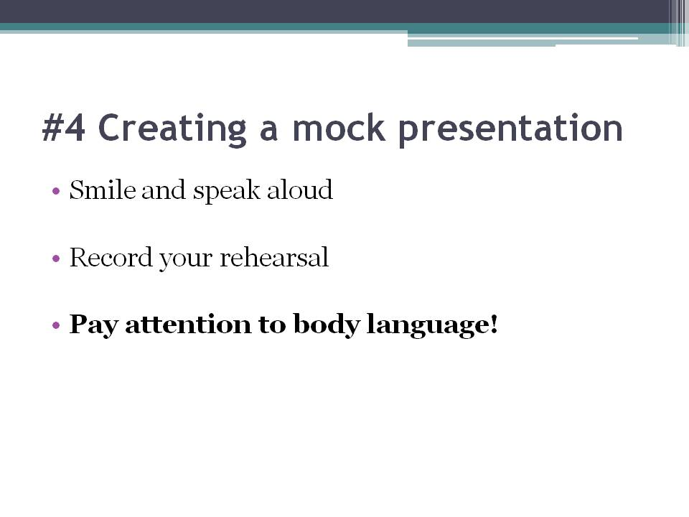

#4 Creating a mock presentation

The one way to eliminate stress and fear before your presentation day is to rehearse. Consistent practice will not only significantly boost your confidence, but it will also help you remember and become more accustomed to your material. Let me run through with you the basic structure of a rehearsal.

First, memorize your opening sentence. This is crucial as once you’ve got into the beat of things, you’ll realize that the rest flows in more smoothly. Next, memorize your main points in order of your presentations. Try to come up with acronyms for your points and run them in your head consistently while preparing. Also, remember your transitions. In between each point, remember your choice of transition into the next point. Relate your transition sentence to your main point and you will easily recall it during your actual presentation. Lastly, remember your stories. The best way to do so is not to create stories, but to use actual personal experiences. This way you won’t have to try to hard to memorize details and feelings, but the story itself will come naturally to you and even if you forget the flow of the story, you’ll have your memory to help you.

While practicing, it’s important to smile and speak aloud, even if you’re alone. Believe me when I say that presenting in your head is not the same as speaking it aloud. Simulating an actual presentation even when alone can help you build confidence and help you create the atmosphere of an actual presentation. When I say simulate - I mean go all out. Smile, use gestures, refer to your visual aids, practice your posture - all this may seem silly, but it really helps increase your energy and enthusiasm, indirectly injecting this same energy into your audience on the real day.

When you simulate your presentation to an actual audience, start by getting your friends and family to help you out. If you get nervous when speaking to a large audience. Start small. Start out practicing to an audience of 2 - your parents or siblings perhaps. Gather their feedback and move on to a larger practice group of 4. Ask your friends for a hand and get them to sit in and provide you with their honest opinions. Then move on a practice group of 8, and repeat this process to a larger group of friends. Remember to obtain feedback from every group and reflect on your flaws and the specific things that you can improve on. Remember to ask your audience to be critical and nitpick on all your presentation flaws. You want to be able to learn from your mistakes, big or small, before the real thing.

Another important thing to do is to record your rehearsal. Record it in video format if you can. Why do I suggest recording? This is so you can reflect on your own presentation aside from your audience. Put yourself in the shoes of a viewer or listener and identify your mistakes or less glorious moments. Focus your attention on the pacing and timing of your speech as well and take notes for your following practice.

Lastly, your body language is particularly important as they send subliminal messages to your audience. Walk straight and tall, make constant and firm eye contact with your audience, smile constantly and use gestures to help inject some versatility and movement into your presentation. Not only will this convey a less wooden message to your audience, this can also help to dissipate nervous tension.

To quickly summarize - practice, reflect, practice. That’s the key to presentation success. Rehearse to small groups, slowly increase the headcount in those groups and obtain feedback from your mock audience. Record your rehearsals and analyze your own speech and presentation style and place particular emphasis on your body language.

Day 2

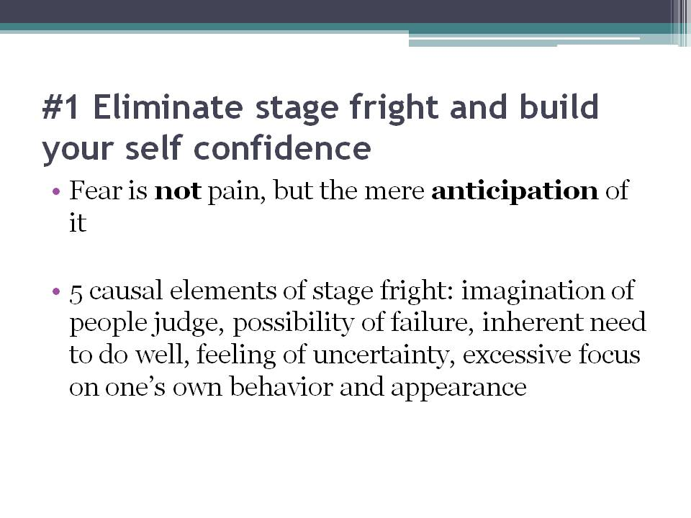

#1 Eliminate stage fright and build your self confidence

Are you the type who cringes at the thought of walking on stage? The type that is overcome by sweaty palms, a racing heartbeat and shaky legs the moment you take your first step on that platform. If you are, don’t think of yourself any less. Fear of public speaking is highly common and almost everyone has experienced or felt it at one point in their lives. In fact, statistics show that some degree of public speaking fear/nervousness affects an estimated 95% of all speakers. In fact, recent studies in the United States of America have shown that fear of public speaking actually ranks higher than fear of death! Don’t you find it bizarre that the general American public fear facing crowds more than the prospect of Heaven or Hell?

That being said - let’s dissect this common feeling in order to understand it better. Let’s start with what is fear? Fear is defined as the anticipation of pain. Yes, you heard that right. Fear is not pain, but the mere anticipation of it. There are 5 causal elements of stage fright: 1. The perception or imagination of the presence of people who will judge, 2. The possibility of failure, 3. The inherent need to do well in order to avoid failure, 4. The feeling of uncertainty of whether one can do well and 5. An excessive focus on one’s own behavior and appearance.

The reason why we experience uncomfortable symptoms like light-headedness, sweaty palms, and increased heart rate is because this fear is actually a psychological condition that is manifested physically via these symptoms! So in order to prevent these symptoms, we have to conquer fear. How do we do this? By attacking every one of the 5 causal symptoms. In this session I’ll reveal 6 very simple steps to help you overcome your fear of speaking to audiences on stage.

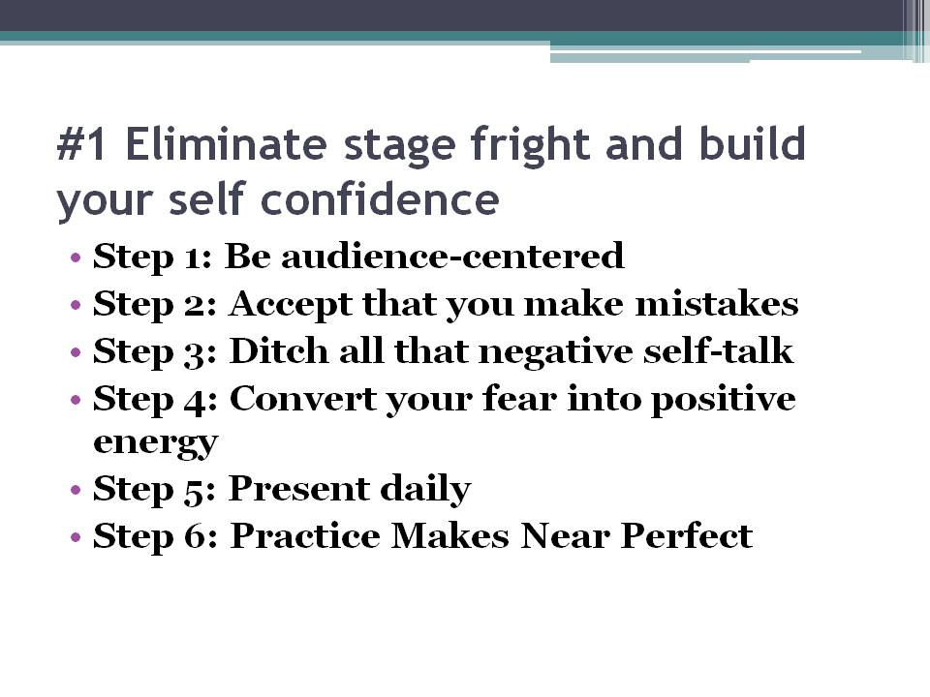

Step 1: Be audience-centered.

In order to conquer fear, you have to remember that your presentation is not about yourself. Instead, it’s really about your audience. Focus on the needs of your audience, rather than on how you will perform and your fears will automatically disappear. The truth is, no one really cares about your voice, or how you look. Your audience is more interested in what you have to offer them. Concentrate on how you can provide optimum benefit to the people listening to you. If you’re selling a product, concentrate your efforts on selling the benefits of your product to your audience. If you’re sharing a learning, focus on how they can benefit or take action with what you have to share. Whether or not you are telling a story to build rapport, or delivering a sales pitch, a focus on your audience’s needs can help take your mind off your fear.

Step 2: Accept that you make mistakes

No one is born a perfect speaker. Good public speakers aren’t born, they’re made. Do you think Martin Luther King, Jr. delivered that amazing speech on his first try? That man was a Reverend who had delivered countless speeches and sermons prior to “I Have A Dream”. Even he made mistakes. So if you screw up, does it really matter? What’s most important is that you learn from your mistakes. If you notice a mistake during your speech, no one in the audience is going to disapprove if you backtrack to amend that mistake. In fact, it’s more credible that you do. In order to improve and be better, you have to take risks. Think of your presentation as an opportunity to benefit and convey amazing information to your audience. And remember this, Thomas Edison failed thousands of times before he invented the light bulb. And did it deter him? No. His inventions are spread across the world today and are constantly innovated upon. Do you want to be a Thomas Edison, or the chump who’s too afraid to leave his house for fear he falls?

Step 3: Ditch all that negative self-talk

If you remember the causal elements of stage fright I just mentioned, you’ll notice that all of those elements have a recurring theme - negative self-talk. Just like how the seeds of a tree determine its fruits or end product, what happens on the inside has a significant impact on our outside. This means that our actions and fears are actually influenced by our subconscious minds Negative self-talk not only drains your energy, it demotivates you. In order to overcome this, you need to start replacing all that negative self-talk with positive ones. Stand in front of the mirror daily, straight-backed and with a smile on your face. Replace your “I can’t do this”, “People will judge me” and “I’m going to suck” thoughts with phrases like “I feel energetic!”, “I’m prepared and focused!”, “I am delivering value to my audience!” and “The audience is my friend, not foe.” Eventually, the attitude and actions will follow. Like the famous saying goes, you’ve got to fake it till you make it.

Step 4: Convert your fear into positive energy.

Did you know that aside from your thoughts, you can also convert your physical behavior? You can help convert stage fright symptoms with the power of visualization and belief. For example, did you know that sweaty palms and a racing pulse are also symptoms of an adrenaline rush? So instead of attributing negative thoughts to your racing pulse and sweaty palms, why don’t you decipher these physical reactions as an adrenaline rush? As excitement and optimism for your presentation? This not only decreases your fear, it also immediately turns on the alertness and energy switch in your body. Your physical reactions are what you make them to be.

Aside from that, if you find yourself blanking out midway through your presentation, don’t panic. You can choose one of two routes. You can either be honest, tell your audience you forgot and need to refer to your notes and laugh it off with a joke on aging, or you can side track a little and tell your audience a story of a funny thing that happened to you recently. Both routes give you a minute to realign your thoughts, give the audience a minute to laugh and humanize you to your audience.

If dry throat is your stage fright symptom, tell the organizers beforehand to prepare a glass of warm water or tea (cold drinks constrict your throat and cause more discomfort than comfort) and take an occasional sip in between your points. This not only gives your audience a minute to take notes, you are also offered a moment to recoup your thoughts and ready yourself for your next section. Remember to only take a sip though, and not gulp the entire glass down.

Step 5: Present daily

I’m not just talking about practice (I’ll get into that later), I’m talking about incorporating it into your daily life. To tell you the truth, speaking to an audience is no different from your day-to-day interaction with the people around you. In a conversation, you’re either trying to convey a message or sell an idea - both require the same skills and elements in a public presentation. Once you grasp and understand this concept, this can help you feel much more confident and powerful on stage. When you’re talking to your friends, try to visualize yourself on a stage and imagine that they are your audience - how they react to you in that scenario is really how they will react to you on stage, with the exception that your friends can actually interrupt you. One way of gaining confidence and overcoming fear, is to incorporate elements of your public speaking skills into your daily conversations with your boss, colleagues, friends and family. Take careful notice of how they respond and you can easily tweak your conversation style to produce your desired reactions.

Step 6: Practice Makes Near Perfect.

I’m repeating this point from our last session because it is that important. This may seem simple enough, but the truth is the more you know your material, the more confident you’ll be as the fear of forgetting will disappear almost entirely. Like I mentioned previously, practice your speech on 2 people, then 4, 8 and so on. Carefully assess your feelings whether it’s confidence or anxiety throughout the presentation and record your practice groups’ feedback. Again, remember that it doesn’t have to be perfect and instead will get better as you go along and practice more. With time and sufficient practice, your presentation skills will drastically improve to the extent where you no longer have to worry about embarrassing yourself or screwing up.

Before we move on to the next point, let me quickly summarize the 6 steps to help overcome stage fright: 1. Be audience-centered, 2. Accept that you can make mistakes, 3. Ditch your negative self-talk, 4. Convert your fear into positive energy, 5. Present daily, and 6. Practice makes near perfect.

Now that you’ve got the basics of presentation preparation and the steps to eliminate stage fright down to a T, let’s move on to personalizing your presentation.

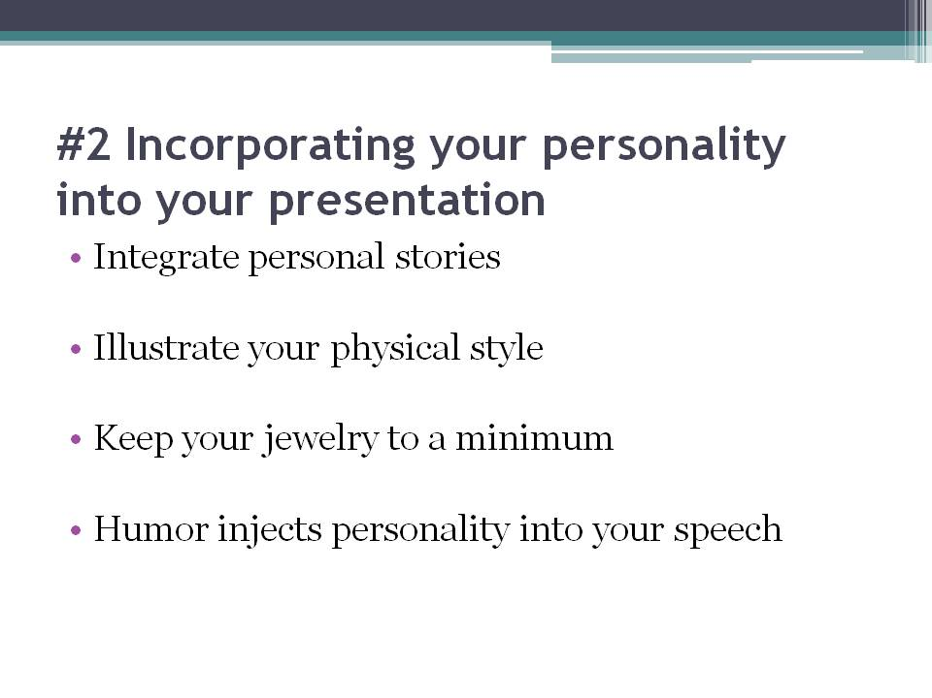

#2 Incorporating your personality into your presentation

One common trait among great presenters is that they have a distinct style which makes your speech memorable and helps inject your personality into your presentation. This helps keep your audience excited. Obama often incorporates slogans and refrains in his speeches, and Steve Jobs is a visual-zen master who designs strategic placements of empty slides in order to make his images stronger, and more prominent when they appear. Like Obama and Steve Jobs, you need to allocate time to focus on conveying your style in the most exciting manner possible.

One way to incorporate your personality is to integrate personal stories in your speech. This is not only an effective way of exposing your audience to who you are, it also helps them relate with you at a more emotional and personal level. One kind of personal story that usually does the trick is the success / hero story. You can speak of yourself as someone who overcame a huge obstacle in life that is relevant to your topic of presentation. This not only allows the audience to relate, sympathize and empathize with you, but also adds some credibility and authority to what you are about to share with them.

Another way of embodying your personality in your presentation is to illustrate your physical style. In other words, by how you dress. It’s important to look the part of the message you’re trying to convey. Top Internet marketer, Frank Kern’s, selling point is freedom. This is why whenever he speaks to audiences, he’s in surf shorts, a loose t-shirt with his hair in a wild disarray - he’s subliminally conveying the message of freedom to his audience. That being said, there are a few guidelines you should take into account when deciding what to wear on stage.

Firstly, keep your jewelry to a minimum. Adorning yourself with too much “bling” can distract your audience from your speech and the only thing they’ll take back with them at the end of your presentation will be how bright and shiny you were. Secondly, stay away from overly colorful articles of clothing. A pair of pants with stripes in 5 contrasting colors will only remind them of a clown from their childhood, and not a person of authority. That being said, overly monotonous clothing may help blend you into the background, making you irrelevant and completely unmemorable to your audience. Your clothing should only reiterate your point, not run the show. Always remember that the audience’s main focus should be on what you have to share with them, and nothing else.

Humor is another great way to inject some personality into your presentation. Not only can it help grasp your audience’s attention, it can also liven up the atmosphere. However, if you choose to use humor in the presentation, make sure your jokes are original, and not cliche. Try not to make fun of members of your audience and instead turn the joke on yourself. For example, if you are a person of short stature, you may want to poke fun at your height to illustrate a point that is relevant to your speech. If you notice that your jokes are falling flat on the audience, don’t be dejected. Punctuate them with short, nonchalant quips such as “Damn, I’ll remember to keep that to myself the next time.” or even “Crap, my mom thought it was funny. I’ll remember not to ask for her advice on humor next time”.

At the end of the day, incorporating personality basically means be yourself. Your audience may not be psychic, but they will be able to see through a false persona. Therefore there is no better physical presentation than your genuine self. So relax, loosen up, and remind yourself to have a great time. A relaxed presenter who’s enjoying his or herself automatically opens up the audience and loosens them up. Your audience is a mirror of who you project yourself to be.

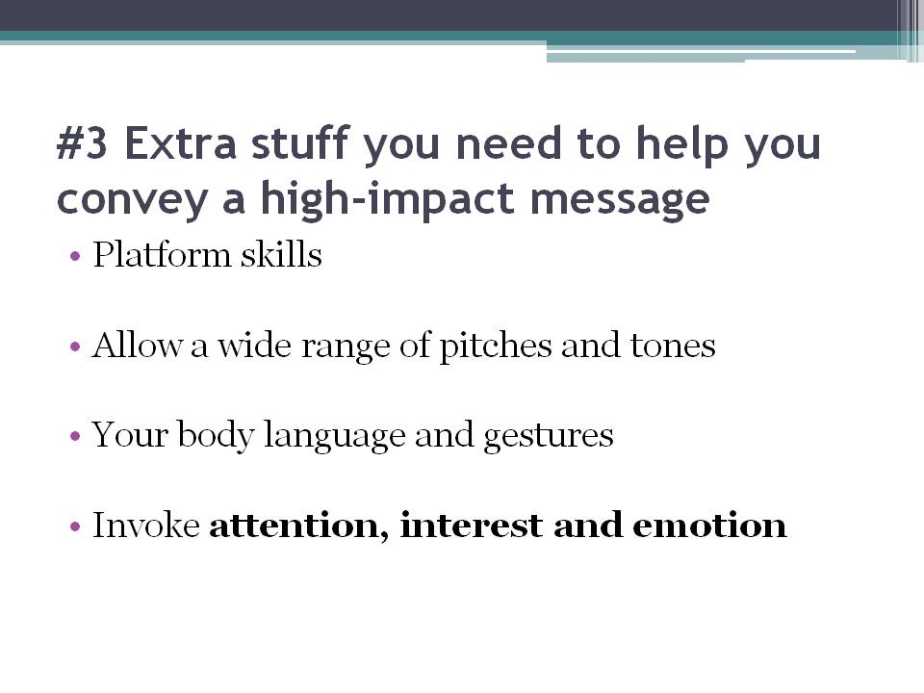

#3 Extra stuff you need to help you convey a high-impact message

Let me share with you some extra elements you can add to give your presentation that extra “zing” it needs to go from good to great.

Platform skills play a pretty crucial role in getting your audience to not just pay attention to you but to also get them excited and enthusiastic about your message. The pacing of your presentation, the pitch, tone and volume of your voice and even your vocal variety play important roles in helping you convey your message effectively. These tools help you clarify and support your message, emphasize your ideas, and even dramatize your message. Consistently maintaining a high volume and loud tone of voice will make you come across as excessively authoritative or aggressive, while using low volumes and soft tones may make you come across as too timid and decrease your credibility as a speaker and the lack of variation will make you sound too monotonous.

The best and most effective route is to allow yourself a wide range of pitches and tones. Adding variety to your vocal pattern is a surefire way to engage your audience’s attention and reinforce key ideas to them. In addition to that, a well-timed moment of silence or pause can help you further emphasize certain ideas, or in some situations, dramatize your message with a little suspense or anticipation. Some good uses of pauses include pausing after you tell a joke to provide emphasis, and give your audience a moment to quieten their laughter. Another good use of the pause is right after you’re introduced to your audience as it gives them time to refocus their attention on the presentation.

Aside from your tone of voice, your body language and gestures are also important components in relaying a more meaningful and memorable speech by adding punctuation. Did you know that the human body contains more than 700 muscles? It’s sad to know that only a handful of those muscles are used by speakers. Speakers tend to focus most of their attention in the search of the perfect words and the most precious points, thereby forgetting that our bodies speak louder than words ever could. When I say body language, I don’t mean using your arms and fingers in a death grip clutch on a poor lectern, or frenetically clicking on your PowerPoint slides - I mean allowing your body to move naturally.

While a good message is important in a presentation, your effectiveness as speaker is really about your ability to invoke attention, interest and emotion in your audience through non-verbal communication. An amazing message conveyed with terrible body language does not get the point across. Why is that? Because your listeners don’t only judge you and your message based on what they hear - they also take in to consideration what they see.

When speaking to an audience, your body can be used as a very effective tool for adding emphasis and clarity to your words. It also plays a very important role in convincing your audience of your sincere feelings, your earnestness in educating or sharing with them, and your enthusiasm about your topic. No matter the purpose of your speech, the exterior self that you project must be appropriate and relevant to what you say.

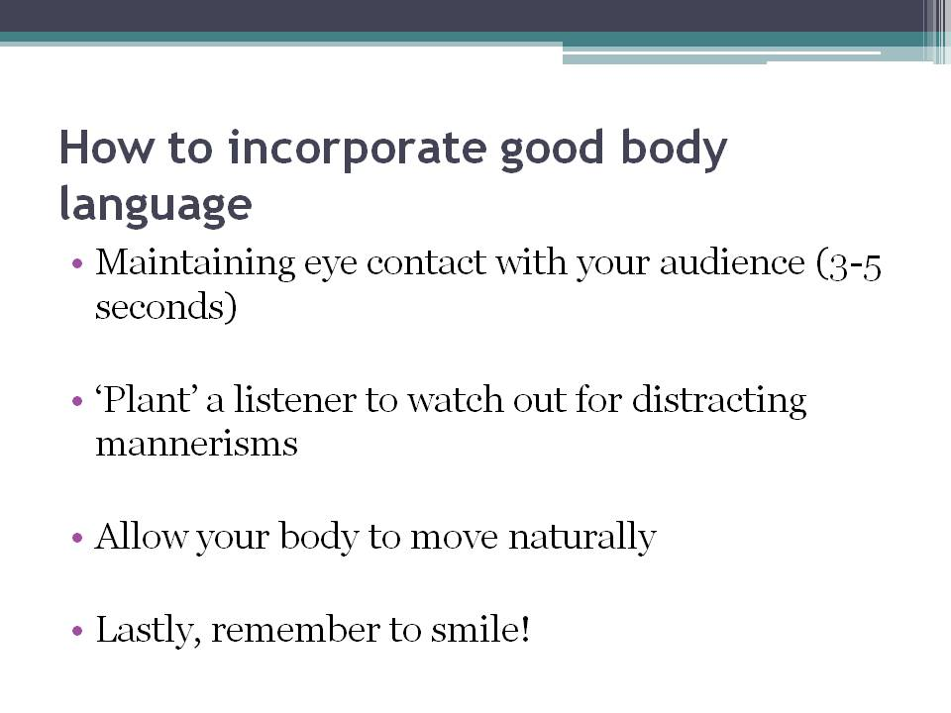

Here are a few ways you can incorporate good body language into your presentations. Firstly, you can start with maintaining eye contact with your audience. You should not just continuously pass your gaze throughout the room, instead, try focusing your sight on individual members of the audience. You’ll find that you can create a bond with them just by looking them directly in the eyes for 3-5 seconds. By using eye contact, you make everyone in your audience feel involved and connected to you.

Secondly, while in a practice session have a listener watch out for distracting mannerisms such as fidgeting, twitching, lip-biting, or key jingling. All these traits distract your audience from the key point of the message and focuses their attention on your nervousness and fear. You then immediately discredit yourself of any authority that you have on what you’re talking about. You automatically seem unsure, and decrease the amount of trust your audience has about your message.

Thirdly, allow your body to move naturally by moving from one spot of the stage or platform to another. A good example is to walk to the other side of the stage as you move on to your next point, or move toward the audience when you ask a question. These subtle moves help your audience subconsciously visualize your transition from a point to another and help emphasize certain topics.

Lastly, remember to smile and actually express your emotions with your face. A smile can go a long way in helping the audience open up to you. That being said, constantly smiling throughout the entire speech only makes you look clinically insane. A variety of facial expressions that are relevant to what you’re speaking about at the time can help you further punctuate your message. Surprise, curiosity, sadness, anger - these are but a handful of emotions that you can use while telling your audience a story in order for them to properly visualize it.

In summary, platform skills and effective use of body language can help you further punctuate your message and deliver a killer presentation. The keys to using them wisely? Variety and relevance. Always vary your tone of voice and body movements and always use them with relevance to whatever you’re saying at the time.

Day 3

Now that we’ve covered crafting your presentation, personalizing it and making it extraordinary, we can move on to more advanced stuff. In this session, we’ll talk about ways to help you deal with an audience you’ve never met before and how to connect with them. In addition to that, we’ll also cover the important, and often nerve-wrecking Q&A session that normally follows a presentation.

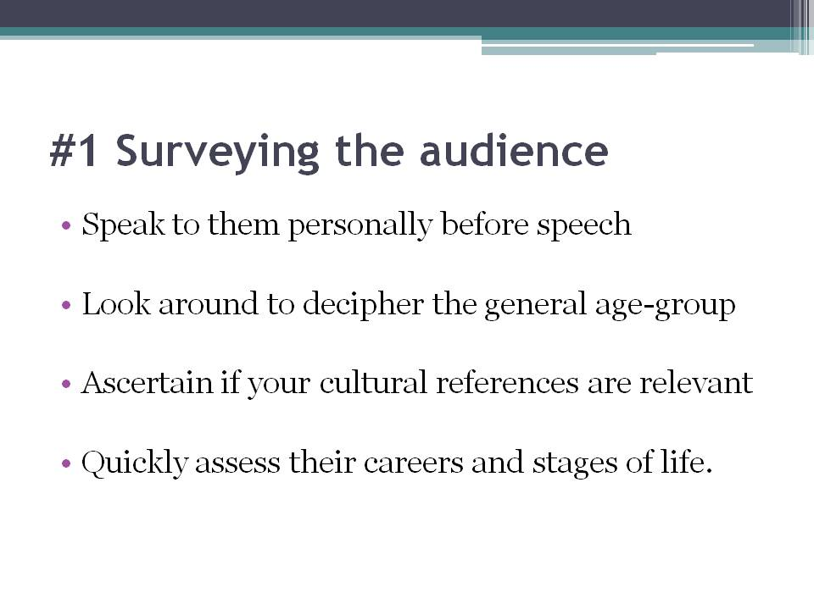

#1 Surveying the audience

Another core component of a killer presentation is audience interaction. The final part of any presentation - answering questions from the audience - can help you build trust and further establish your credibility as an expert on your subject. The thing is, this part of the presentation is the one part where you have close to no control over. Therefore the first step to succeeding in this arena is to getting to know your audience better.

Prior to your presentation, you should do a quick survey of your audience. There are a few ways you can do this and these methods are completely dependent on the nature of your presentation. If you’re one of several speakers presenting to a large crowd of people, you may want to take a few minutes to mingle with your audience before your speech. Speak to them, look around to decipher the general age-group, ascertain if your cultural references are relevant and quickly assess their careers and stages of life. However, if you’re speaking to board of directors of a large organization or several organizations, you may not have the luxury of mingling casually before you present. In that situation, you may want to do a quick background research of these specific individuals and their respective company profiles. If you’re unable to do both, you can easily ask the organizer for the expected or targeted audience profile and work from there.

Here’s why you should go through all this trouble and why it’ll be worth it. By being aware of the characteristics and demographics of the people you speak to, you will be able to effectively tailor your presentation and pick your supporting points, anecdotes or analogies in order to reiterate what you need to say. Speaking to a group of 15-year-old students, for example, is very different from speaking to a group of 19-year-old students... much less an audience of professionals.

You’ll find that audience-surveying is especially important when you’re doing a technical presentation. In situations like that, you’ll find that you need to assess your audience’s level of awareness before you even craft your presentation so as to not bore or overwhelm them. Great public speakers understand that mistakes can always be overcome with connection, and information are greater shared with connection. If your audience is connected to you, you’re less worried about forgetting a point, making an awkward statement or even looking slightly disheveled. You’re less anxious about what ifs such as “what if I fall?” “what if the projector breaks down and my slides are gone forever?” or “what if I fart on stage?”. With a connection, you’re automatically less worried as all will be forgiven.

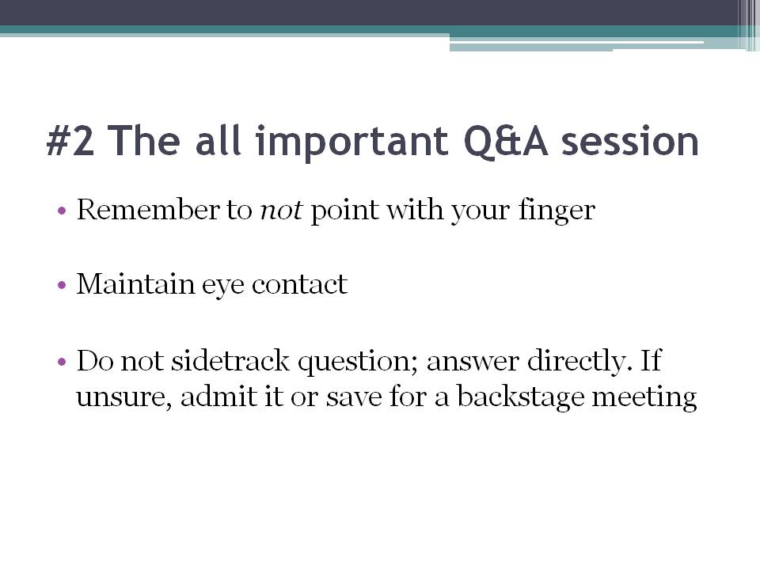

#2 The all important Q&A session

It’s not farfetched to say that most presenters are extremely relieved and extremely worried at the same time when they reach this stage of their speech. They’re relieved that most of the talking is now over, but their also deeply anxious about the type of questions that will come flying their way. If you find yourself in this position, remember to keep your cool and remember that the session is still within your control.

The general rule of thumb for dealing with questions is to listen to the question, answer it, and then quickly bridge it to your agenda. If you need a minute to think and gather yourself and the answer to your question, repeat the question for the rest of the audience. This also helps the rest of the audience be aware of what exactly you’re addressing.

Firstly, when selecting which member of the audience’s question to answer, remember to not point at them with your finger. In many cultures, this gesture is perceived as rude and aggressive. Instead, gesture at them with your palm faced upward, as if welcoming someone.

While answering the question, remember to maintain eye contact with the person who asked the question. If can, give him/her a concise response and then move on to the next question. Maintain your credibility by offering facts to support your answer and always be diplomatic. If you’re asked a question that’s unrelated to your topic or completely outside of your field of expertise, you can politely explain the reason to why you’re choosing to not answer that question or even covering the topic in your subject. If you find yourself faced with a question asked in an aggressive or particularly argumentative tone, my suggestion is to answer it briefly and quickly, and then immediately move on. Some questioners may try and trap you into a debate which is usually time-consuming and will bore the rest of the audience. Try your very best to avoid falling into an open debate with that individual by rephrasing their question and quickly moving on to the next.

There will also come a time when you find yourself unsure of the answer to someone’s question. Truthfully, I believe in being honest and telling him/her that you really aren’t sure if the answer you offer may be accurate. However, you can take it an extra mile by promising to gather information about the answer to be sure and get back to them. It’s important, then, that obtain that person’s contact information from the organizer or the person himself and actually provide him with an answer, or at least an acknowledgment. Alternatively, you can offer the question to other members of the audience and see how they respond. In some situations, you may find yourself greeted with silence the moment you open up the Q&A session. Many speakers immediately move to close the session altogether and exit the stage. I personally think that if you’re greeted with silence, you’ve either (a) lost the audience completely, or (b) got a really shy audience. If you’ve done everything by the book and how I’ve advised you to, the latter option is the most definitely the correct answer. If you’re speaking to a primarily Asian audience, you’re less likely to be bombarded by questions. In that situation, I would suggest not closing the session and instead share the answers to some frequently asked questions about your presentation topic. This way you’re covering all bases and making sure that you deliver added value to your audience now that the presentation is over.

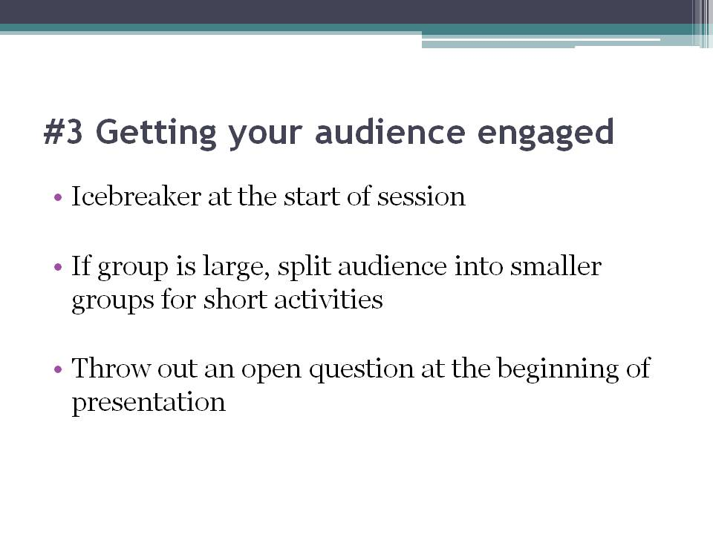

#3 Getting your audience engaged

One of the keys to a truly successful presentation is audience participation. By involving your audience in the presentation, you’re helping them focus and better-relate to the material you need to present, therefore encouraging them to take immediate action with the ideas you shared after the session. If you’re wondering why you need to go the extra mile to get your audience to participate and actually remember and apply what you say, let me give you the answer. Your role as a speaker is not just to convey a message, but to also facilitate the absorption and the application of this message. A truly successful speaker truly cares for the audience.

One of the fastest and simplest ways to stimulate audience participation is in the form of an ice-breaker at the very start of the session. Ice-breakers are particularly useful for long seminars, but can also be used in shorter presentations to allow your audience to move around and shake things up before you actually begin. A good ice breaker is to start with asking all members of your audience to stand up and introduce themselves to at least 2 people around them and offer a short, quirky, random fact about themselves.

If you’ve got time and a large group, you can split your audience into small or partner groups and involve everyone in various activities. In order to fully maximize audience participation, you can even get these groups to elect a leader or a representative to share their findings and voice their unanimous thoughts.

During long sessions, it’s easy for the audience to get either groggy or antsy. What you can do is to get them to start your session with warm-up exercises. Ask them to stand up, raise their arms up, and swing about, or even allow them to have a nice cat stretch. Another quirky way of getting them involved, interacting and awake is to get everyone to stand up and give the person next to them a 2-minute back rub. You can also get them up and moving by playing upbeat music and getting them in the groove for a quick shake and dance before you actually begin.

Another good way to actually connect with your audience and get them to interact with you is to throw out a question to them at the beginning of your presentation. A common but smart question is to ask them what they expect to gain from your session or speech and at the end of the session, you can review these points with members of your audience to show exactly what you’ve covered. This is a good way to allow your audience to connect the dots by themselves and actively search your presentation for key takeaways.

In some occasions, you may find yourself wishing to gather input from your audience. Let me share with you a simple and effective method to do so. This method is called the “Ben Franklin Close”. The only materials you need are a whiteboard or flip chart and a marker. You start off by splitting the paper into two lengthwise and labeling each side of the paper - pros and cons for example. Then, you get your audience to shout out answers and ideas while you write them down. This not only stimulates their tired brains and gets them thinking, it also gives you a moment to quickly analyze your presentation, recoup, and decide on your next actions.

It’s not unusual to be faced with awkward, less-sociable members of the audience. In more conservative cultures, open and casual communication and interaction is not the norm. In order to avoid awkward silences and stony glances, you can pre-select a handful of volunteers. This gives them time to prepare, and fills an other-wise overly quiet session. In the situation where you have no response to your question, be prepared to actually answer it yourself. However, it’s important to not take the silence too personally. Every public speaker has faced a stony or less sociable audience at a point in time.

One good way to encourage interaction is through “bribes”. No, I’m not talking about the illegal kind. I’m referring to small “secret” gifts you can throw out to more bold and daring members of your audience to “reward” them for their participation. This can include inexpensive custom pens, notepads, folders or even keychains.

Last but not least, you have to remember that the goal of audience involvement and interaction is to inspire them to feel good about themselves and to motivate them to take action. Remember that people act for their own reasons, not yours. Therefore it’s important to provide them with an environment within which they can act in response to your message.

Just a quick summary -- introduce ice-breakers into your session, suggest warm-up exercises or dance sessions to keep an upbeat and high flow of energy, get to know your audience and what they want to help them achieve their goals, offer small, inexpensive gifts to get them to participate and remember the goal of audience interaction.

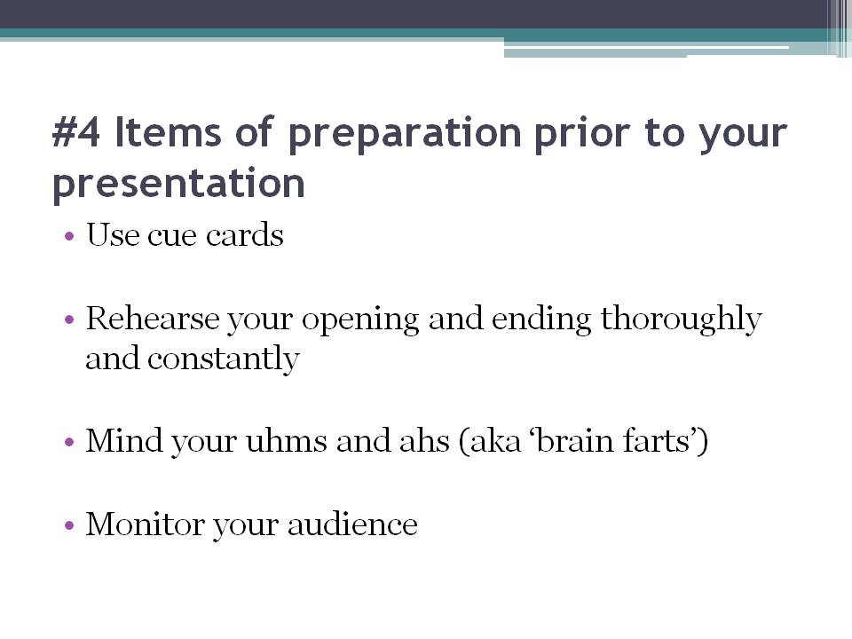

#4 Items of preparation prior to your presentation

Now that you’ve covered the basics of speech preparation, speech personalization, vocal energy, body language and platform skills, audience surveying and audience engagement and interaction, you can move on to the final part of this course - the key items you need to get ready prior to your presentation. Here are a few quick tips to help make your presentation smooth-flowing.

First up, use cue cards. If you’re unsure of your ability to memorize an entire speech, don’t fret - no one really expects you to. With paper, you can easily create quick, point-formed cue cards to help you through an entire presentation. Many public speakers make the mistake of printing an entire essay on a bunch of cards. Do not fall into that trap. Remember the outline of your speech that you made at the very beginning of the speech-crafting process? Get that outline and flesh it out into a handful of cue cards. Sprinkle short notes and reminders like “Tell funny pool story” or “Show chart about gender differences” throughout your cue cards instead of the full story itself. Cue cards are extremely useful elements in any presentation and like any other speaker out there, don’t hesitate to employ the correct use of it.

Rehearse your opening and ending thoroughly and constantly. I said this before, and I will repeat it again because this is how important it is - Introduction is King. Remember that the first few minutes, or even seconds, of your speech determines the mood and flow of the rest of your presentation... and it even determines the amount of audience focus and attention.

Do not over-rehearse. Remember that it’s really important to be natural. Rehearsing too much shows, and not in a good way either. While preparation is key, you need to make sure that your presentation is conversational and natural, not memorized. Rehearse the full speech the night before your presentation, and then stop. Enough. Forget it.

Mind your uhms and ahs. That may sound silly, but in retrospect, it really isn’t. You may not notice your ahs and uhms, but trust me -- your audience does. Watch what you say and keep them to a minimum.

Monitor your audience. The moment you sense that you’re losing them and they’re phasing out of the presentation, adjust your speech, improvise and project yourself forcefully. Alternatively, at this point of the presentation, you can quickly break and get them to get up and get moving with a quick warm up exercise before quickly repeating your initial points and moving on to the next one.

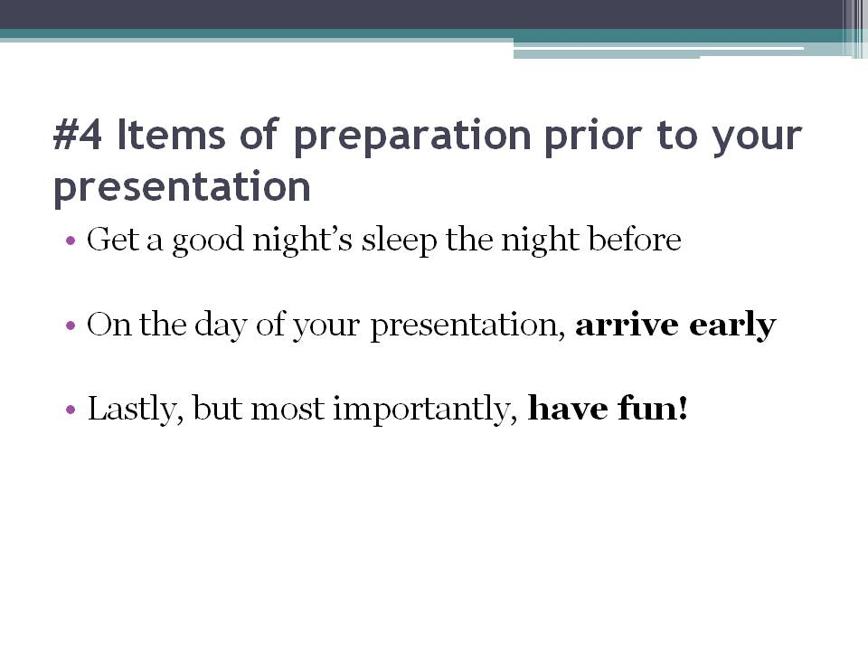

Get a good night’s sleep the night before. Why do I say that and why is it important? Because lack of sleep results in frayed nerves -- and that shows. When your not sufficiently rested, you’re more likely to succumb to nerves, hand jitters and stutters -- all of which damage not only your presentation, but your credibility. Avoid all that and if you’re not a coffee-person, don’t try to compensate for the lack of sleep with a cup of coffee. You’ll find that caffeine does not just keep you awake, it keeps you overstimulated and less composed.

On the day of your presentation, arrive early. There are many benefits to arriving early. Firstly, you won’t enter the venue like a rushed wreck and waltz onto the stage unprepared. Arriving early allows you to run your points quickly in your mind prior to actually presenting. You’ll also come across as cool, calm and collected - important components in conveying confidence. When you’re not rushed, you’re also less likely to forget things. Secondly, like I said before in this session, arriving early allows you to mingle with your audience and get to know them better. Stand outside while they’re registering and converse with them. Find out their hopes and dreams and know what they hope to gain from your session, or even why they attended at all. Simple things like that not only help you determine the tone of your presentation, but allow your audience to connect with you and get to know you. This way, you know that you already have friends in the audience and will be less likely to fear and be nervous.

Lastly, but most importantly, have fun. It may sound impossible, but there are neurons in your brain called “mirror neurons”. Like their names, they mirror the actions of the person before you. If your energy is high and your tone upbeat, your audience will mirror the exact same thing. Vice versa if your energy is low and your tone monotonous - they will mirror boredom. You need to enjoy what you’re talking about, and inject passion and enthusiasm into your presentation. In other words... you need to have fun.

